Supplement I – Thermistor and BaRAGRABA 2.0 Construction and Calibration
This supplement describes the construction and callibration of the multichannel thermistor and data capture application. This process took place in consultation with an independent electrical engineer and the Wits School of Electrical and Information Engineering. Calibration of the device took place at the Wits School of Physiology using a standardised thermometer for reference temperature measurements.
The circuit diagram (Figure 4 -1) below describes the construction of the multichannel thermistor used for temperature measurement.
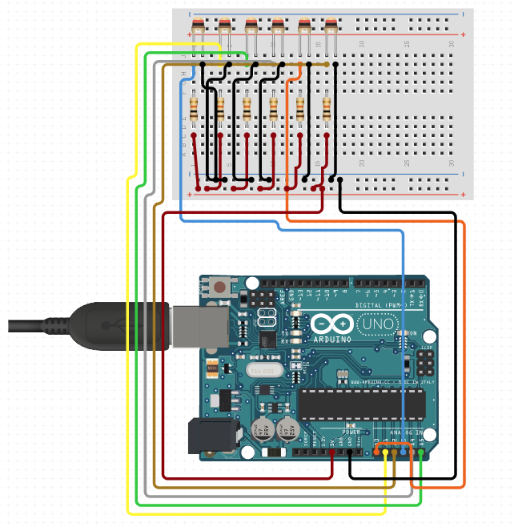
Figure 4-1 Circuit diagram
Table 4.1 describes the components used in the construction of the multichannel thermistor
Table 4-1 Multichannel thermistor components
Component | Manufacturer/Serial Number | Notes
Microcontroller | Arduino Uno  Arduino LLC Inc, 10 St. James Avenue, Boston Massachusetts, 02116, USA | https://www.arduino.cc/
Thermistors | 10K ohm glass bead thermistors DHT0B103J3953SY Communica Electronics | 6 thermistors used and labelled T1 – T6
Resistors | 10k Ohm
Table 4-2 contains the source code for the microcontroller. Note in line 14 of the microcontroller code the values C1, C2 and C3 correspond to the A,B and C coefficients required for the Steinhart-Hart equation.
Table 4-2 Multichannel thermistor source code
- #include <OneWire.h>
- #include <DallasTemperature.h>

- #define ONE_WIRE_BUS 5

- OneWire oneWire(ONE_WIRE_BUS);

- DallasTemperature sensors(&oneWire);

- float Celcius=0;
- int sensorPins[] = {A0, A1, A2, A3, A4};
- float R1 = 10000;
- float logR2, R2, T;
- float c1 = 1.009249522e-03, c2 = 2.378405444e-04, c3 = 2.019202697e-07;

- void setup() {
- Serial.begin(9600);
- sensors.begin();
- Serial.println();
- Serial.println("t6,t5,t4,t3,t2,t1,");
- }

- float readSensor(int number) {
- float value;
- value = analogRead(number);
- R2 = R1 * (1023 / value - 1);
- logR2 = log(R2);
- T = (1.0 / (c1 + c2 * logR2 + c3 * logR2 * logR2 * logR2));
- T = T - 273.15;
- Serial.print(T);
- Serial.print(",");
- return value;

- }

- void loop() {
- sensors.requestTemperatures();
- Celcius=sensors.getTempCByIndex(0);
- Serial.print(Celcius);
- Serial.print(",");
- float val;
- for (int i = 4; i >= 0; i--) {
- val = readSensor(sensorPins[i]);

- }
- Serial.println();
- delay(500);
- }

Figure 4-2 illustrates the modified 3-way Luer Lock used to manage inline fluid temperatures

BaRAGRABA 2.0
BaRAGRABA 2.0 was designed to read data transferred from the multichannel thermistor and save it in an appropriate format for further management and interpretation. The application was coded on Python 3.8.2 (v3.8.2:7b3ab5921f, Feb 24 2020, 17:52:18). Table 4-2 contains the source code for this application.
Table 4-3 Source code for BaRAGRABA 2.0
- import tkinter as tk
- import csv
- import time
- import serial
- root = tk.Tk()
- root.geometry('400x250')
- root.title('BaRAGRABA 2.0')
- IDEnterFrame = tk.Frame(root, bg='grey', bd=6,pady=10)
- IDEnterFrame.pack()
- ExpTimFrame = tk.Frame(root)
- ExpTimFrame.pack()
- transFrame = tk.Frame(root)
- transFrame.pack()
- secondtestFrame = tk.Frame(root)
- secondtestFrame.pack()
- StartExpFrame = tk.Frame(root, bg='grey', bd=6,pady=10)
- StartExpFrame.pack(fill=tk.X)
- #######################ExpIDEnter##############################
- # Enters the experiment Identifier. Needs to update the experiment ID so that a csv filename
- # is the same as the experiment ID
- en = tk.StringVar()
- ent = tk.StringVar()
- experimentID = ''
- def subID():
- global experimentID
- ent.set(en.get())
- experimentID = en.get()
- ExperimentNr = tk.Label(IDEnterFrame, textvariable = ent).pack(fill=tk.X)
- expLabel = tk.Label(IDEnterFrame, text='Enter Experiment ID: ').pack(side=tk.LEFT)
- expEnter = tk.Entry(IDEnterFrame, textvariable=en).pack(side=tk.LEFT,pady=8)
- expButt = tk.Button(IDEnterFrame, text='Save ID', command=subID).pack(side=tk.LEFT)
- ##########################ExpTime############################
- # Experiment duration = airbubble transit time from T1-T5 + 5seconds
- # The start timer will be pressed when the flow starts and stopped when
- # bubble is distal to T5.
- # This transit time will be used to calculate the number of items collected
- # from the Arduino.
- # items collected = transit time(seconds) * 2 (500ms sampling)+ 10 (5s * 2)
- d = tk.StringVar()
- d.set('0')
- dd = 0
- starttime = None
- def start():
- global starttime,dd
- if starttime is not None:
- d.set(f"Running")
- print("timer is running press STOP")
- else:
- starttime = time.perf_counter()
- print(f"TIMER RUNNING @ {starttime:.2f}")
- def stop():
- '''Stop Timer'''
- global starttime,d,dd
- if starttime is None:
- d.set(f"Stopped")
- print("Timer is stopped press start")
- dd = (time.perf_counter() - starttime)
- d.set(f"{(time.perf_counter() - starttime):.2f}")
- print(f"TIMER STOPPED @ {time.perf_counter():.2f}")
- starttime = None
- print(f"Transit time is: {dd:.2f} seconds")
- timStart = tk.Button(ExpTimFrame, text="Start Timer", command=start).pack(side=tk.LEFT)
- timStop = tk.Button(ExpTimFrame, text='Stop Timer', command=stop).pack(side=tk.LEFT)
- timTransit = tk.Label(transFrame, textvariable = d).pack(side = tk.LEFT)
- SecLabel = tk.Label(transFrame, text='seconds').pack(side = tk.LEFT)
- ###################Enter Transit time for Second TEst##############
- # enter prev experiment duration
- # will save the time and assign it to variable dd
- # dd used to calculate duration of arduino collection
- ttime = tk.IntVar()
- def SubTim():
- global dd
- dd = ttime.get()
- timEnter = tk.Entry(secondtestFrame, textvariable = ttime).pack(side = tk.LEFT)
- timButton = tk.Button(secondtestFrame, text='Submit Experiment Time', command = SubTim).pack(side = tk.LEFT)
- ##################StartExp##############################
- # Recording of temperature begins with this button.
- # 2 functions are possible. Firstly RArduino() collects information
- # from the Arduino. The number of items collected are calculated from
- # the transit time as explained in ExpTime above
- # The second function saves the data as a csv with filename entered in
- # ExpIDEnter. It then clears the data[] list and the input fields on the BaRAGRABA app and
- # prepares for a new experiment.
- data = []
- def RArduino():
- global data, ser, experimentID, dd
- e = ent.get()
- experimentID = e
- duration = (dd*(1/0.5)+10)
- ser = serial.Serial('/dev/tty.usbmodem14101', 9600)

- for i in range (int(duration)):
- b = ser.readline()
- serial_n = b.decode()
- string = serial_n.rstrip()
- data.append(string)
- time.sleep(0)

- ser.close()
- print("FINISHED READING")
- print(data)
- print(len(data))
- time.sleep(1)
- print("Reminder: Review Data and Save")
- def P2CSV():
- global data, experimentID, d
- print("Saving Data for experiment nr: ", experimentID)
- with open('%s.csv' %(experimentID), 'w', newline='') as f:
- for i in data:
- writer = csv.writer(f)
- writer.writerow([i])
- data.clear()
- strd = str(dd)
- with open('testime', 'a', newline = '') as t:
- t.write(f'{experimentID} ----- {strd} \n')
- time.sleep(2)
- print("DONE saving experiment nr: ", experimentID)
- d.set(0)
- en.set('')
- ent.set('')
- expStart = tk.Button(StartExpFrame, text='Record Temperatures', command=RArduino).pack(fill=tk.X)
- saveExp = tk.Button(StartExpFrame, text='Save Data', command=P2CSV).pack(fill=tk.X)
- root.update_idletasks()
- root.mainloop(

Multichannel thermistor calibration
The multichannel thermistor was calibrated against the Bat-12 Microprobe Thermometer (Physitemp Instruments INC, 154 Huron Avenue, Clifton, NJ 07013, USA). The calibration took place at the WITS University School of Physiology teaching laboratory. The temperature, as measured by the BAT-12, and resistance of the thermistors were measured at three temperatures. These temperature-resistance pairs were entered into the SRS Thermistor Calculator (Stanford Research Systems, available at https://www.thinksrs.com/downloads/programs/therm%20calc/ntccalibrator/ntccalculator.html). A, B and C coefficients calculated by the SRS Calculator were entered into the multichannel source code in line 14, and correlate with c1, c2 and c3.

